Converting AutoCAD files to COLLADA format Method I

JaamSim uses *COLLADA (.dae*) type files to load 3D content. Since AutoCAD cannot export directly into *COLLADA*, we must first convert the original CAD files (.dwg) before opening them up in JaamSim. This can be done by opening the AutoCAD files in *3dsMAX* and exporting in *COLLADA* form. This set of instructions runs through the process of converting and opening AutoCAD files in JaamSim.  
  
Troubleshooting can be found on Page 4.  
Protips can be found on Page 12.

1. Open *3dsMAX*. Close the welcome window that pops up.
2. 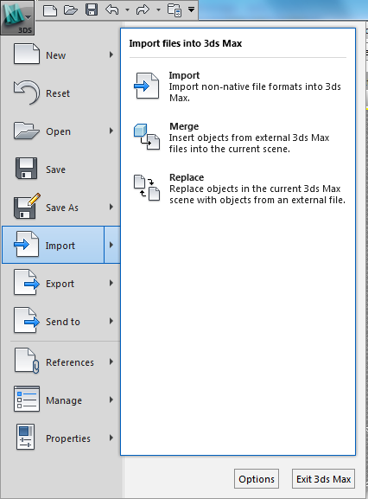Click on the **Home M** button found at the top right hand corner of the window. 🡪 Click **Import**. Locate and open the desired file.

1. A *Proxy Object Denied* box appears. Select **Yes.**
2. The following *Options* box will appear. Under the drop down menu of <<*Derive AutoCAD Primitives by>>¸select* ***colour.***Make sure the <<*Create one scene object for each AutoCAD Architecture one>>* and <<*Use scene material definitions*>> are both checked. Leave the *Rescale* box unchecked as it tends to cause serious errors. If rescaling is needed, see steps 8 – 10.
3. Set <<*smooth-angle*>> to 31. Set <<*Maximum Surface Deviation for 3D Solids>>* to 5.0.

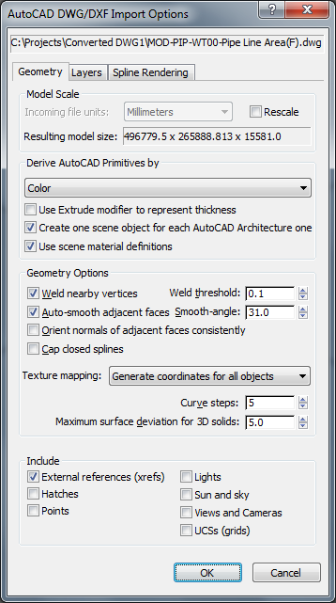

1. Switch over to the *layers* tab on the same window. Make sure that all layers are checked. Hit **OK.**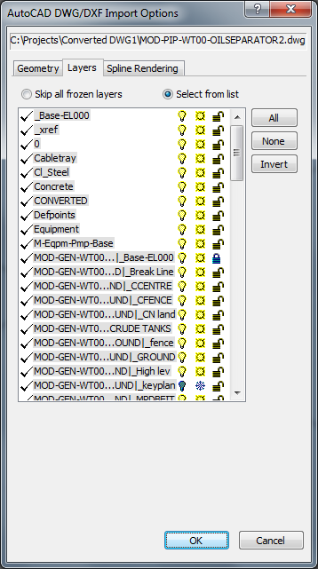

**PROTIP**: Pressing **u on the keyboard** in *3dsMAX* will change to orthographic mode, making it much easier to zoom and pan.

1. Once you’re satisfied with your model in 3dsMAX, select **Home M 🡪 Export**. Pick a file name and save as an *openCOLLADA.DAE* file. *Note: Make sure you export in openCOLLADA.DAE form and not Autodesk COLLADA. If the openCOLLADA plugin is not installed on your machine, a download can be found here http://collada.org/mediawiki/index.php/OpenCOLLADA*

**RESCALLING**

The following steps walk through rescaling your COLLADA files.

1. Locate the COLLADA file in windows explorer and 🡪 **Right click 🡪 Open With 🡪 Notepad**++. Note: In order to proceed, Notepad++ must be installed on the machine. If this is not possible, regular default notepad can suffice, but is not recommended.
2. Press **ctrl + f** and search for “unit” (without quotations). Look for the following line of code:

*<unit name="inch" meter="0.0254"/>*

1. Replace the multiplier to be consistent with the scale of the original drawings. For example, if the drawings were composed in a scale of millimetres, the multiplier would be 0.001. The unit name is arbitrary. Replace for aesthetics. **Save** and close.

Note: *If a simulation is already open in JavSim, saving the edit to the unit multiplier into the same file will not translate into simulator space, even if you reload. Normally in windows, such a procedure should work. It doesn’t in this case simply due to the nature of JavSim (as of build 22- June2013). To avoid this, you will have to save your edited .dae file with a different name, or restart the project from scratch.*

Troubleshooting

A step by step set of instructions to avoid/solve common problems.

1. Missing objects in *3dsMAX* or in JaamSim (i.e. transparent pipes, missing pipes, etc).
2. Z Fighting Errors. (i.e. random flickering or still colours inside objects).
3. Error Message in *3dsMAX.* <<*Unable to Attach this file; the file may be missing, corrupted, or may not contain valid data.>>*
4. Smoothing Errors (i.e. pipes appear polygonal).

---.

**Problem i : Objects Appear to be Missing or Transparent in *3dsMAX.*** This is a common issue with piping objects from the Bentley AutoPLANT Plugin. It is solved by converting all the incompatible objects and meshing them together into one grand layer. The new layer will be in ACIS format, which can be read by *3dsMAX.* The following steps walk through how this is done.

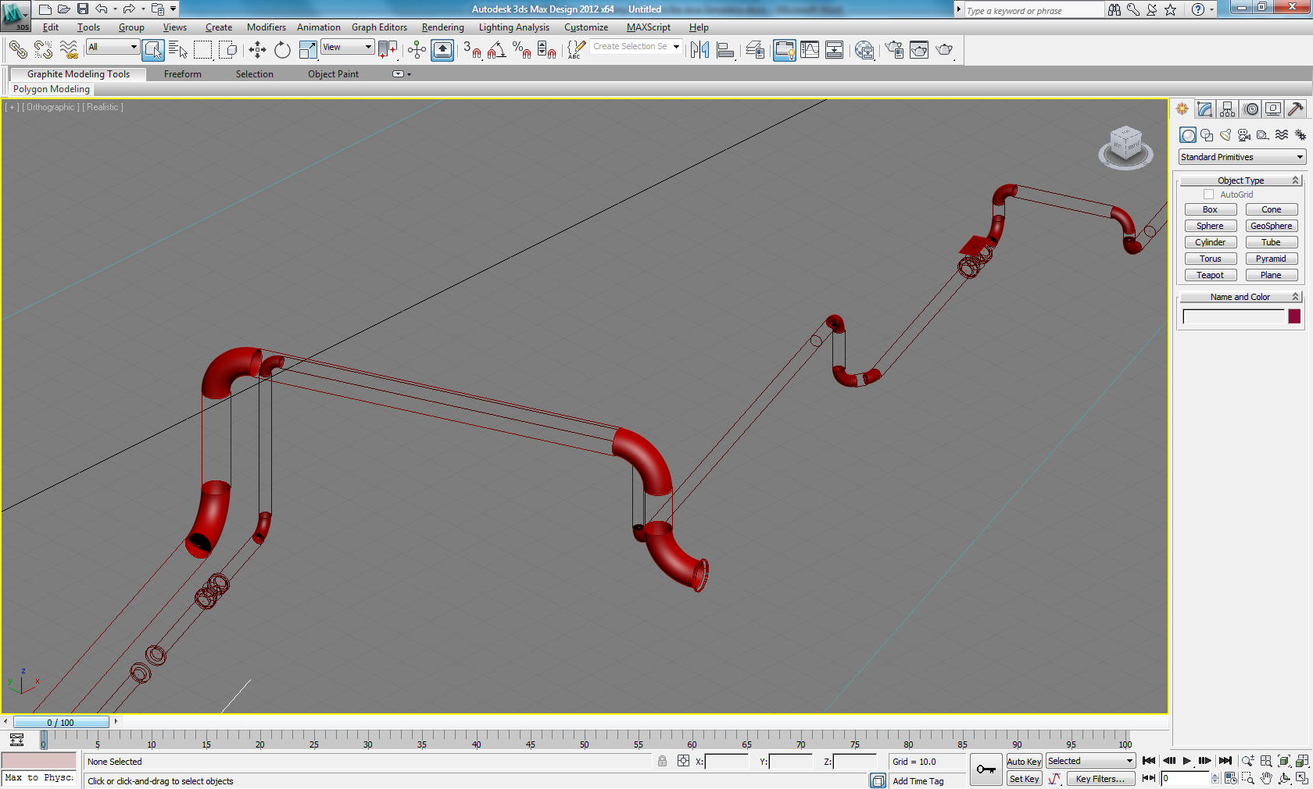  
  
  
---

**Pipes here appear transparent in *3dsMAX.***

1. Open AutoCAD. Click **Home A** 🡪 **open file***.*
2. A *Projectwise Log-in* box will appear. Click **cancel***.*
3. Select and open the *.dwg* file you wish to work with.
4. Select ***Home A.*** In the search box labelled <<*Search Commands>>*, type in “piping”. Select the piping module that appears.

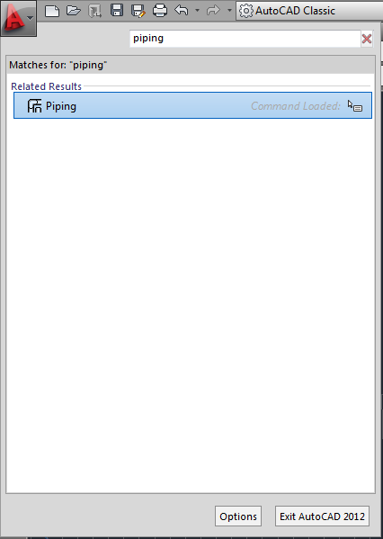

1. Once the module is launched, go to:

**Piping 🡪 Piping Tools 🡪 Representations**

This will launch the following box:

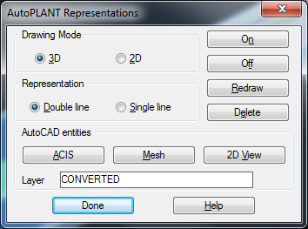

1. Type in a name for your new converted layer (i.e. CONVERTED). Click on **ACIS**.
2. 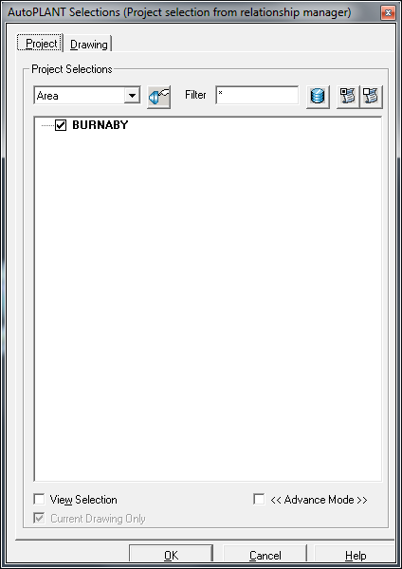Select the project in which the object is from. Ensure that you have checked the box before hitting OK.

Make sure the desired project is checked. If there is more than one, select all.

1. Click ***Done*** on the *AutoPLANT Representations* box.
2. Your new layer should now appear on the menu toolbar. Make sure it is there before proceeding.

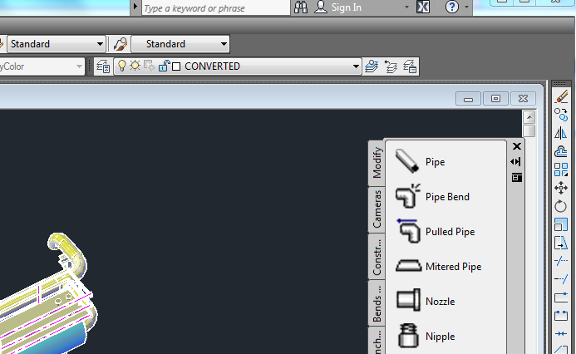

1. Click ***Home A 🡪 Save As****.* Click **Cancel** on the projectwise log-in box. Type in a new name for your new .dwg file. Save it to a destination of your choice.

*Note: To avoid Z fighting errors, see Problem ii below.*

---

**Problem ii** : **Z Fighting Errors (i.e. random flickering or still colours inside objects ).** Oftentimes, Z fighting errors will ensue after piping objects have been converted together into a common layer. This is caused by two objects fighting to occupy the same space. This can be solved by turning off the original layers. The following highlights the steps in this process.

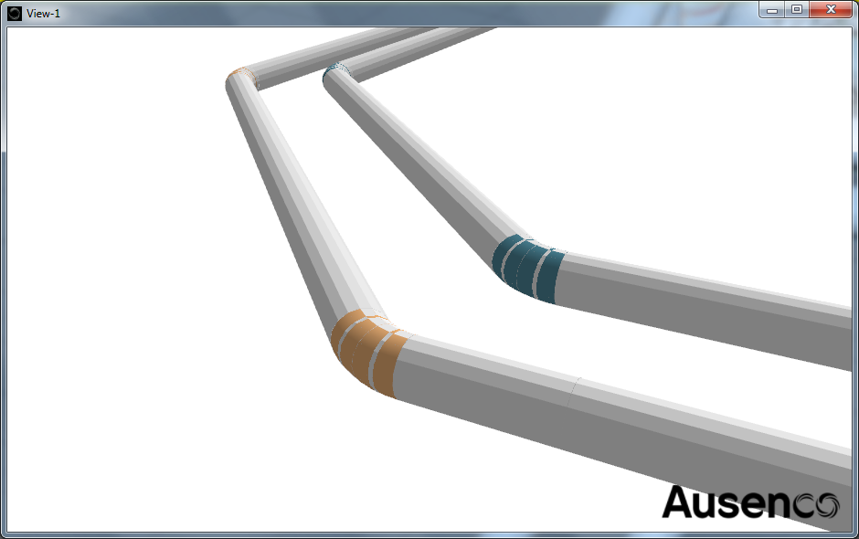

An example of Z fighting. Two objects try to occupy the same space at the same time, causing a flickering, Z fighting effect.

---

1. Open up your file in *3dsMAX* or JaamSim and make notes on which pipes or objects have Z fighting errors.
2. ****Open your new AutoCAD (.dwg) file (i.e. the file with the new converted layer).
3. Open the **Layers Properties Manager ,** located on the layers toolbar.  
   .



1. Find and turn off your new converted layer by clicking the yellow light bulb. This will allow you to view the original incompatible layers clearly. If this is your current layer, a message asking for confirmation will pop up. Confirm.
2. Hover your mouse over what you suspect to be a conflicting object (i.e. a pipe curve). Make a note of the layer name. Repeat until all the conflicting layers are identified.

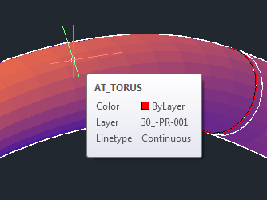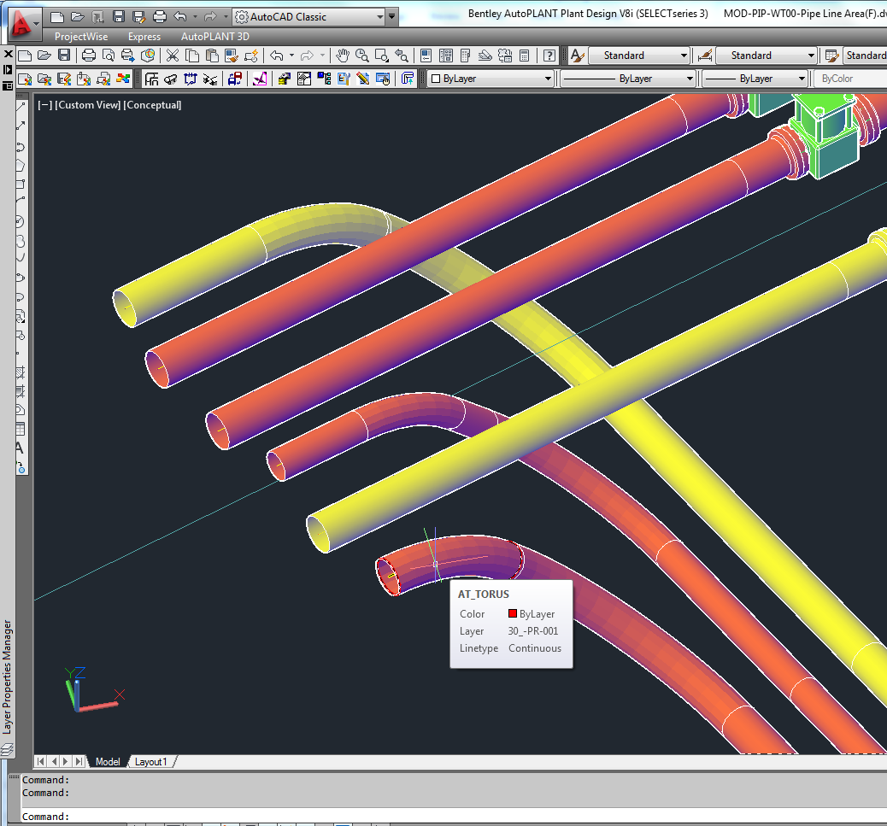



1. Open the **Layers Properties Manager** and freeze all the noted conflicting layers.This can be done by clicking the yellow sun.
2. Turn on the converted layer by clicking the lightbulb. You should now see the converted pipes.
3. **Save** your file and open it with *3dsMAX*.
4. Under the layers tab, select <<*Skip All Frozen Layers>>*.

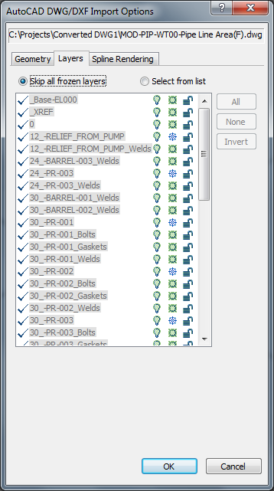

1. Export into openCOLLADA.dae and open it in JaamSim. The Z fighting should now be fixed.

---

**Problem iii** : Sometimes, when opening files with *3dsMAX,* the following error might ensue.

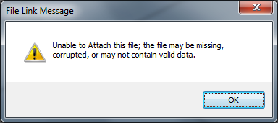

This type of error can be caused by the rescaling options in *3dsMAX.* If you get this error, avoid using the rescale feature in *3dsMAX* when importing (leave the **Rescale** checkbox blank). Instead, use the method outlined on page 3.  
  
  
---

**Problem v**: Pipes appear polygonal despite playing around with the importing settings in *3dsMAX.* This can be caused by some sort of *3dsMAX* glitch. Thankfully, it can be solved relatively easily.

1. Open up your file in *3dsMAX*. Press **ctrl + a** to select all.
2. Select the Modify tab on the far right hand side. In the *Modifier List,* select **smooth**.

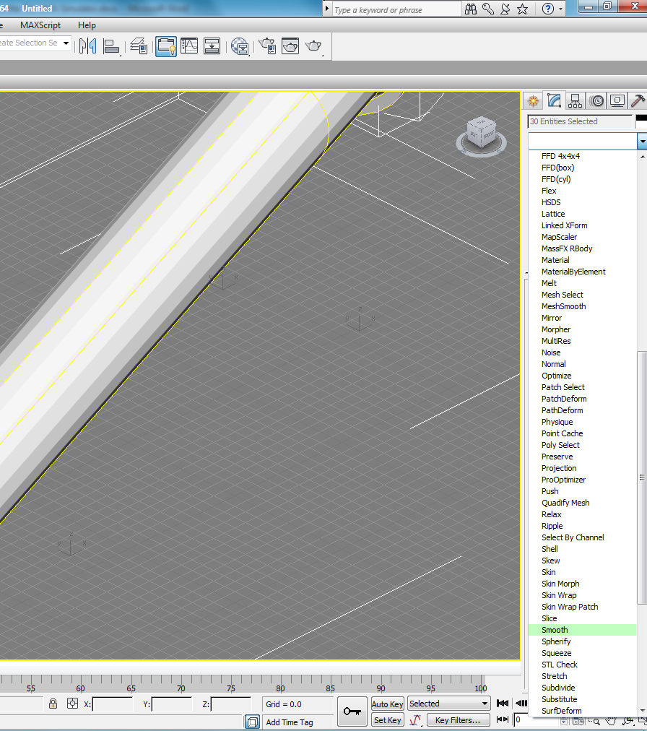

1. Check the <*<Auto Smooth>>* box And select the necessary threshold angle. 31.0° will usually suffice.
2. **Save** and quit.

Protips

* Pressing **u on the keyboard** in *3dsMAX* will change to orthographic mode, making it much easier to zoom and pan.
* Get rid of shadows in *3dsMAX* by selecting the **view input 🡪 Lighting and Shadows 🡪 Shadows.  
    
  